Virtual Gamepad – User manual

# A brief description of the app

Virtual Gamepad is an Android app that emulates a gamepad on your android smartphone and let you play games on your Linux computer through Bluetooth.

With this app, you and your friends can easily join together in front of a computer and play almost all of your favorite games. With a virtual gamepad you no longer need to bring your hardware gamepad and you can play everywhere you want and at any time.

The app comes with a very simple and logical layout, and the gamepads included are inspired of some of the most famous and recognized hardware gamepads in the world.

The app connects to the computer through Bluetooth and a server application on the computer that emulates keyboard presses. In the server you can set how many players you are, how many buttons each player need and also configure which buttons will be pressed. The last feature applies to games where you can’t change which buttons to be pressed.

Also as with many gamepads of today you can enable both haptic feedback (rumble feature) and accelerometer (simulated gyro).

On the next page follows a user manual on how to install and use the Virtual Gamepad App.

# guide in how-to-use Virtual Gamepad

Hi there, we are very excited about that you have chosen Virtual Gamepad and below you can find guidance manual in how to use and install the app and server.

## installing and configure the server

If you don’t have installed the server before nor have connected your phone to your computer over Bluetooth you need to install Bluez v4, there is a version 5 out but it is not supported at the moment. If you are running Ubuntu Linux just copy paste the line below into a terminal, else check out <http://code.google.com/p/bluecove/wiki/stacks> for the Bluez command for your Linux Version.

*sudo apt-get libbluetooth-dev*

When this is done and Bluetooth is working you will need to download the server application, a link to the server is provided just below from wherever you downloaded the app.

When you have downloaded the file server.jar just go the folder where it is downloaded and write as below. Keep in mind that the computer and the android device need to be paired before starting the server.

*java –jar server.jar*

The server should now be started and should look like below (apart from that your username should be between the [], this was included as an example).

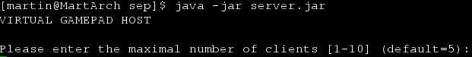

Here you can enter how many players that will be playing (max 10) for this session, please note that you can be fewer than the chosen amount while playing but if you want to add additional players you will need to type “*reloadConfig*” and redo the configuration. Just pressing the enter button will give you the default value.

After choosing the number of players you will be faced with the next question.

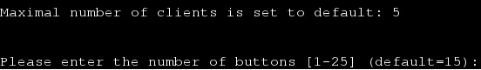

Here you need to type in the number of buttons you will be using per player. If you are just a few players (1-4) you will only need to press enter and all the provided layouts will work. This feature was added because the total value of buttons may not exceed 105, so if you plan to play with a lot of people you will need to do a little bit of counting. Keep in mind that a joystick counts as 4 buttons.

Pressing enter will start the server and you should be faced with the interface as below, otherwise check the troubleshoot manual. You may now leave the terminal (but do keep it running!) and start your game.

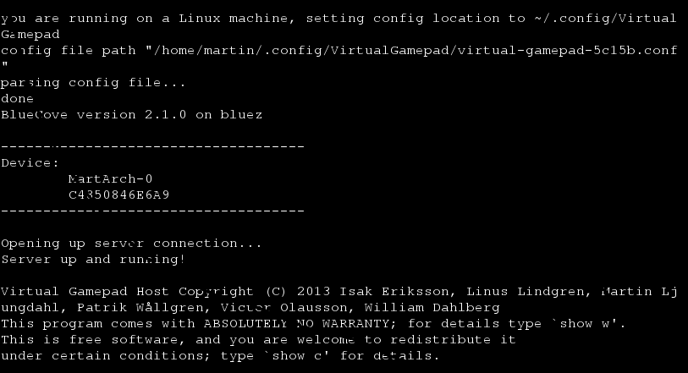

## The App

### Starting the app

When starting the app with your Bluetooth off you will be faced with a question if you want to turn it on, which you will need to answer yes on in order to use the app properly. The question will be displayed in the phones main language.

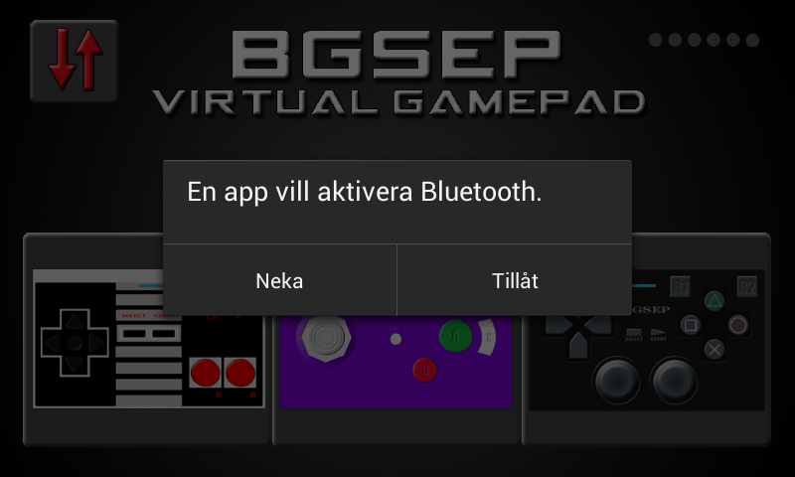

*Bluetooth question in Swedish, pressing the right alternative will start Bluetooth. Pressing the left will show you the main page but the connection won’t work*

If you have paired the device at any time before turning on the Bluetooth will be enough to play with the gamepad.

### Configure the connection

When starting the app and reaching the main page the arrows in the upper left corner will be yellow and turning in a circle – that means that the app is connecting to the server.

If the arrows turn green that menas the app is connected and everything is fine. Pressing the green arrows will dissconect the connection.

If the arrows turn red or if the arrows are red at any time that menas that the app is not connected to the server. Pressing red arrows will make the app reconnect the connection. If the connection do not connect a failuremessage will be displayed at the button of the screen.

### Enable extra features

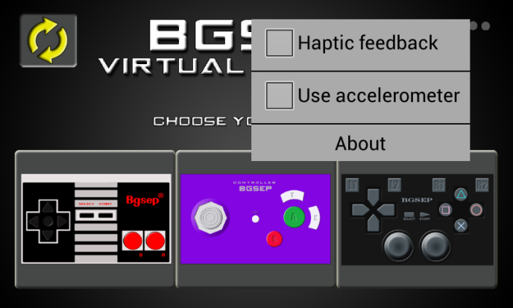

Clicking the dots in upper right corner will display the dropdown enable menu.

Here you can enable *haptic feedback*, which is a rumble feature the makes the device rumble a little bit when a button is pressed.

You can also enable *use accelerometer*, which enabled makes you able to turn the device left and right and assign this as buttons. For example in a car game, turning the device left will make the car turn left if configured. The accelerometer is implemented as a joystick (but can be used with all layouts) with five stages, if you turn the device more to one side that button will be simulated pressed with a higher frequency. For example in a car game the car will make a sharper right turn if you turn the device more to the right.

You can also press the about button which, if pressed, will display the license and conditions.

### The Controllers

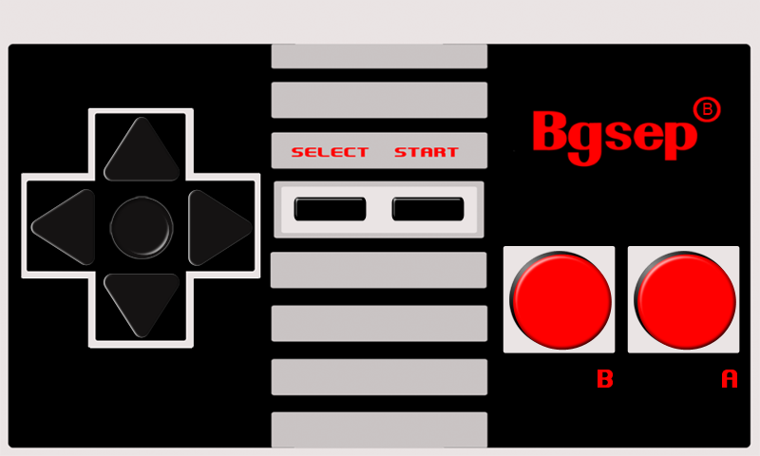

The first gamepad is a Nintendo Entertainment System inspired gamepad with two game buttons, a start and a select button and four directions buttons.

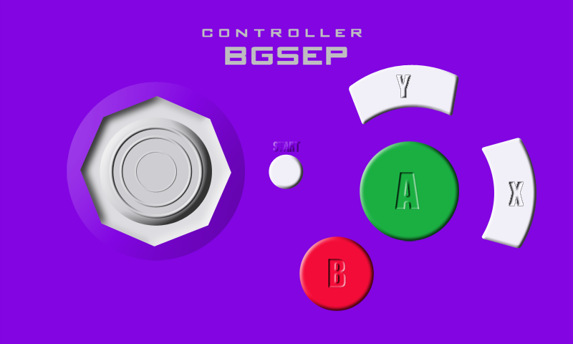

The second gamepad is a Nintendo GameCube inspired gamepad with four game buttons, one start button and a joystick with five states.

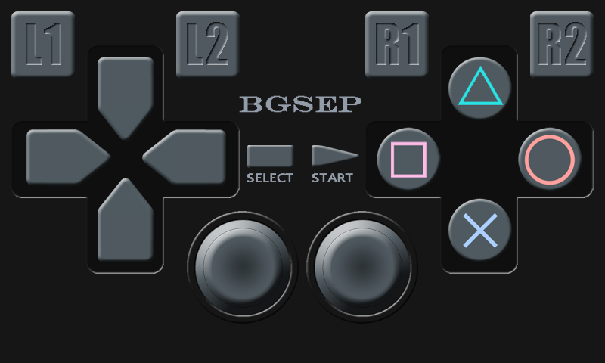The third gamepad is a Sony PlayStation inspired gamepad with four gamebuttons, four shoulder buttons, a start and a select buttn, two joysticks and four directions buttons.

## Troubleshooting